NETWORKING & SYSTEM ADMINISTRATION LAB – 20MCA 136

1. Create a directory structures as shown below. FISAT Day1, Day2,Day3 are folders and f1,f2,f3,m1,m3,m3,c1,c2 are files.

exam@debian:~$ mkdir FISAT
exam@debian:~$ cd FISAT
exam@debian:~/FISAT$ mkdir DAY1
exam@debian:~/FISAT$ mkdir DAY2
exam@debian:~/FISAT$ mkdir DAY3
exam@debian:~/FISAT$
exam@debian:~/FISAT$ cd DAY1
exam@debian:~/FISAT/DAY1$ cat > f1
f1
This is the content of file f1
exam@debian:~/FISAT/DAY1$ cat > f2
f2
This is the content of file f2
exam@debian:~/FISAT/DAY1$ cat > f3
f3
This is the content of file f3
exam@debian:~/FISAT/DAY1$ ls
f1 f2 f3
exam@debian:~/FISAT/DAY1$ cd ..
exam@debian:~/FISAT$ cd DAY2
exam@debian:~/FISAT/DAY2$ cat > m1
m1
This is the content of file m1
exam@debian:~/FISAT/DAY2$ cat > m2
m2
This is the content of file m2
exam@debian:~/FISAT/DAY2$ ls
m1 m2
exam@debian:~/FISAT/DAY2$ cd ..
exam@debian:~/FISAT$ cd DAY3
exam@debian:~/FISAT/DAY3$ cat > c1
c1
This is the content of file c1
exam@debian:~/FISAT/DAY3$ cat > c2
c2
This is the content of file c2
exam@debian:~/FISAT/DAY3$ ls
c1 c2
exam@debian:~/FISAT/DAY3$ cd ..

1. Merge the filles m1 and m2 to make m3 in the folder Day2

exam@debian:~/FISAT$ cd DAY2
exam@debian:~/FISAT/DAY2$ cat > m3
exam@debian:~/FISAT/DAY2$ cat m1 m2 >> m3
exam@debian:~/FISAT/DAY2$ ls
m1 m2 m3
exam@debian:~/FISAT/DAY2$ cat m1
m1
This is the content of file m1
exam@debian:~/FISAT/DAY2$ cat m2
m2
This is the content of file m2
exam@debian:~/FISAT/DAY2$ cat m3
m1
This is the content of file m1
m2
This is the content of file m2
exam@debian:~/FISAT/DAY2$

2.Copy the file m3 to Day3 folder under the name c3

exam@debian:~/FISAT/DAY2$ cp m3 /home/exam/FISAT/DAY3/c3
exam@debian:~/FISAT/DAY2$ cd ..
exam@debian:~/FISAT$ cd DAY3
exam@debian:~/FISAT/DAY3$ ls
c1 c2 c3
exam@debian:~/FISAT/DAY3$ cat c3
m1
This is the content of file m1
m2
This is the content of file m2

3. Change the permission of the file f1 with write permission for all users.

exam@debian:~/FISAT/DAY1$ chmod a+wt f1

4. List all process status in your computer

exam@debian:~/FISAT/DAY1$ ps -aux

5. List your presnt working directory

exam@debian:~/FISAT/DAY1$ pwd
/home/exam/FISAT/DAY1

2. Write a shell script to find the area of a circle, rectangle and triangle using switch case.
Program Code

echo "Finding Area"
echo "------------"
echo -e "Menu \n 1.Area of Cicle \n 2.Area of Rectangle \n 3.Area of Triangle \n "
echo "Enter your choice :"
read ch
case $ch in
1) echo "Enter radius : "
read r
area=$(expr 22 / 7 \* $r \* $r)
echo -e "\n Area of Circle = $area" ;;
2) echo "Enter length :"
read l
echo "Enter breadth:"
read b
area=$(expr $l \* $b)
echo -e "\nArea of Rectangle = $area" ;;
3) echo "Enter base :"
read ba
echo "Enter height :"
read h
area=$(expr $ba \* $h \* 1 / 2)
echo -e "\n Area of Triangle = $area" ;;
*)echo "Invalid choice ! Exit"
esac

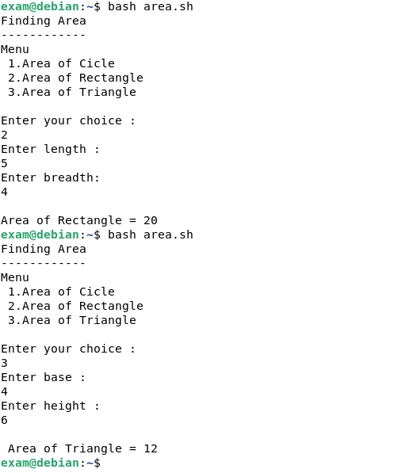
OUTPUT

